|  |
| --- |
| **Tugas Praktikum Tutorial**  **White Box Testing** |
|  |
|  |
| **INSTITUT TEKNOLOGI DEL**  **FAKULTAS INFORMATIKA DAN TEKNIK ELEKTRO** |

|  |  |
| --- | --- |
| **NIM / Nama :** | 1. **11S19006 / Daniel Fernandez Lumbanraja** 2. **11S19022 / Gabryella Apriani Sinaga** 3. **11S19043 / Hari Dominggo Soarest Joab Siburian** 4. **11S19045 / Josua Gaolus Nainggolan** 5. **11S19049 / Albet Mathew Best Nainggolan** 6. **11S19050 / Risky Junior Martua Panggabean** 7. **11S19065 / Aryanti Verina Putri Siregar** |
| **Program Studi :** | **S1 Informatika** |

**Task A**

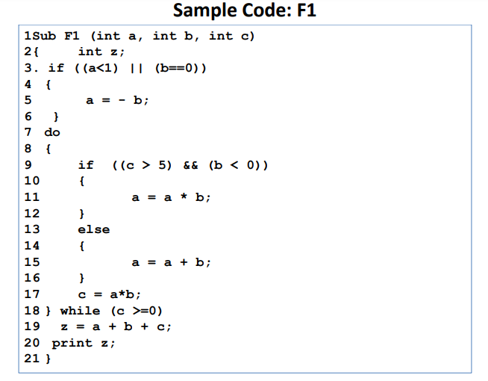

1. Determine the statements, nodes, edges, and branches

2. Draw the control flow graph of the program

Jawab :

|  |  |
| --- | --- |
|  | **Control Flow Graph** |

**TASK B**

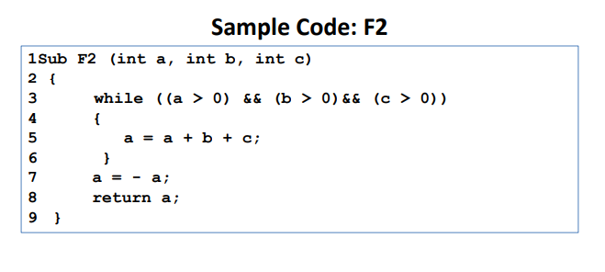1. Draw the control flow graph of the program

Jawab :

|  |  |
| --- | --- |
|  | C:\Users\User-PC\Downloads\Flow diagram B.png |

2. Draw traceability table for a test suite having

test cases covering 100% Decision and

Condition Coverage (D/CC)

Jawab :

a>0) = C1

(b>0) = C2

(c>0) = C3

while( (a>0) && (b >0) && (c>0)) = D

TS-A

C1 = F ; C2 = F; C3 = F, D = F

C1 = T; C2 = T; C3= T , D =T

D/CC = 8/8 * 100 % = 100%

|  |  |  |  |
| --- | --- | --- | --- |
| **C1** | **C2** | **C3** | **D** |
| F | F | F | F |
| T | T | T | T |

TS-B

C1 = F, C2 = F, C3 = T; D =F

C1 = T, C2= F, C3 = F , D = F

C1 = T, C2 = T, C3 = T . D =T

D/CC = 12/12 * 100 % = 100%

|  |  |  |  |
| --- | --- | --- | --- |
| **C1** | **C2** | **C3** | **D** |
| F | F | T | F |
| T | F | F | F |
| T | T | T | T |

3. If a test case T1 (a=0,b=0,c=0): calculate the

percentage following coverage criteria of T1:

1. 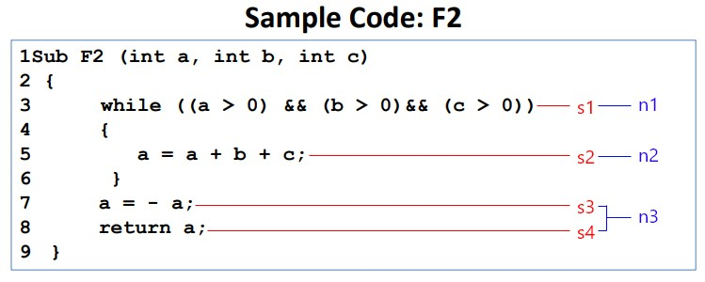D/CC 🡪 disetiap kondisi dan decision harus terdapat pasangan T dan F.

Jawab :

a = 0

b = 0

c = 0

|  |  |  |  |  |  |
| --- | --- | --- | --- | --- | --- |
| C1 | C2 | C3 | D1 | D/CC(%) | |
| F | F | F | F | 4/8 | 50% |

Karena hanya memenuhi kondisi false saja sedangkan true tidak maka T1 tidak memenuhi criteria D/CC 100%.

1. MC/DC

Syarat yang harus di penuhi adalah :

* persyaratan D/CC, yakni

harus mempunyai kondisi dan decision true dan false paling sedikit 1

* memiliki Independent Affect, yakni kondisi dimana perubahan pada kondisi memengaruhi hasil/ Decision.

Jawab:

a = 0

b = 0

c = 0

Test DC

|  |  |  |  |
| --- | --- | --- | --- |
| C1 | C2 | C3 | D1 |
| F | F | F | F |
| T | T | T | T |

Total 8 case, untuk dapat memenuhi test DC

Test MC

Menggunakan tabel terakhir hasil test DC

* pada C1

|  |  |  |  |
| --- | --- | --- | --- |
| C1 | C2 | C3 | D1 |
| T | T | T | T |
| F | T | T | F |

Terdapat 1 Independent Affect pada C1

* pada C2

|  |  |  |  |
| --- | --- | --- | --- |
| C1 | C2 | C3 | D1 |
| T | T | T | T |
| T | F | T | F |

Terdapat 1 Independent Affect pada C2

* pada C3

|  |  |  |  |
| --- | --- | --- | --- |
| C1 | C2 | C3 | D1 |
| T | T | T | T |
| T | T | F | F |

Terdapat 1 Independent Affect pada C3

Maka total terdapat 3 Independent Affect (IA) pada setiap kondisi, yang apabila salah 1 kondisi diubah maka decision berubah

Sehingga:

8 + 3 = 11 kondisi yang harus terpenuhi

4 Kondisi yang sudah terpenuhi

Persentasi:

4/11 x 100% = 36%

Berdasarkan hasil yang diterima, maka percentage yang diperoleh dari data (18 conditions) tersebut adalah: $\frac{1}{18}x 100\%=5,5\%$

c) M-CCJawab:  
 Semua kombinasi yang mungkin terjadi pada setiap kondisi

**Test Case: a=0, b=0, c=0**

**=>** terdapat 3 kondisi, sehingga 23=8 kombinasi yang akan terjadi

while ((a > 0) && (b > 0)&& (c > 0))

Table:

|  |  |  |
| --- | --- | --- |
| C1 | C2 | C3 |
| F | F | F |

Hanya terdapat 1 dari 8 kombinasi, sehingga persentasi nya:  
1/8 x 100% = 12,5%

Tabel kombinasi yang mungkin terjadi dengan 3 kondisi

|  |  |  |  |
| --- | --- | --- | --- |
| C1 | C2 | C3 | D |
| T | T | T | T |
| T | T | F | F |
| T | F | F | F |
| F | F | F | F |
| F | T | T | F |
| F | F | T | F |
| T | F | T | F |
| F | T | F | F |